

King Nahale gate
Etosha East - Etosha National Park
3 Days / 2 Nights
0 Persons

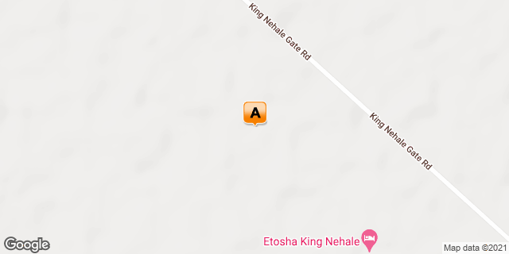

Introduction

Start | Accommodation | Destination | Basis | Duration
Day 1 | Etosha King Nehale | Etosha East | D,B&B | 2 Nights

Key
B&B: Bed and Breakfast. D,B&B: Dinner, Bed and Breakfast

Rate starting from per person NAD6,500.00

Day 1: Etosha King Nehale, Etosha East

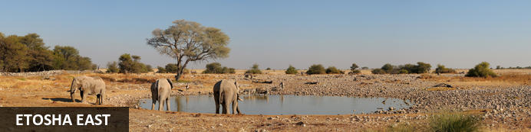
In the vast arid space of Northern Namibia lies one of Southern Africa’s best loved wildlife sanctuaries. The Etosha National Park offers excellent game viewing in one of Africa’s most accessible venues. Zebra and springbok are scattered across the endless horizon, while the many waterholes attract endangered black rhinoceros, lion, elephant and large numbers of antelope. Etosha, meaning ‘place of dry water’, is encloses a huge, flat calcrete depression (or pan) of about 5 000km². The ‘Pan’ provides a great, parched, silver-white backdrop of shimmering mirages to an area of semi-arid savannah grassland and thorn scrub. The pan itself contains water only after very good rains and sometimes for only a few days each year, but is enough to stimulate the growth of a blue-green algae which lures thousands of flamingos.

Overnight: Etosha King Nehale
Etosha King Nehale has been designed and decorated to pay homage to the rich cultural heritage of the area and the majestic riches of the Etosha animal kingdom. Guests of this new Gondwana lodge are immediately captivated by the fascinating atmosphere and warm cordiality that arises from the great attention to detail, whether in the interior design, the choice of food or the small detailed features that they encounter at every turn.
Etosha King Nehale is situated on the Andoni Plains, just one kilometre from Etosha’s northern King Nehale Gate and only 48 kilometres north of Namutoni. At this welcoming lodge each of the 40 spacious chalets has its own plunge pool and views over the plains.
Etosha King Nehale has private access to a remote waterhole in Etosha National Park where the lodge has established its Ontalelo Outpost. The name says it all: ontalelo meaning “view, sight”, “outpost” describes a remote part of a kingdom or empire. Guests can enjoy the fascinating experience of being really close to the wonders of Etosha’s animal kingdom.
To the north, the pulsating cultural vibrancy of the communal areas of the Oshikoto, Oshana, Ohangwena and Omusati regions awaits visitors.
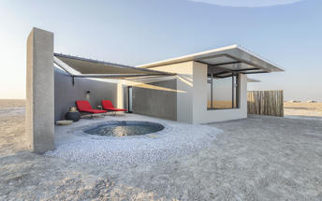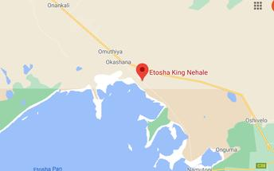

Activities
Etosha Game Drive

Etosha Game Drive
Etosha’s definitive feature is the Etosha Pan, a vast shallow depression, about 5 000 sq km in size. Classified as a saline desert, the expansive white plain of dry water is an unusual setting for game and that which sets Etosha apart from other reserves in Africa. On some days the pan is a shimmering sheet of mirages upon which the animals appear to be floating. A total of 114 animals are represented in the park, including several rare and endangered species such as black rhino and black-faced impala. Etosha’s elephants are reputed to be the largest in Africa, the tallest measuring up to 4 metres at the shoulder. Lion, wildebeest, zebra, cheetah, leopard, giraffe and many others are also seen in the park.

Basis
Dinner, Bed and Breakfast

Day 2: Etosha King Nehale, Etosha East

Activities
King Nahale Lodge Private Hide excursion
Etosha National Park

Etosha National Park
The Etosha National Park is Namibia's premiere game viewing experience, situated in the northwest of Namibia and is an area well known for its wildlife. Vegetation ranges from dense bush to open plains attracting a diversity of wildlife. In the heart of the Park is The Etosha Pan - a shallow depression that covers an area of 5000sq kilometres. Dry and shimmering for most of the year, the pans fill up with water after good rains to a depth which is seldom deeper than 1m. In the dry season wildlife is attracted to perennial springs and waterholes that makes for excellent game viewing. Within the park are three large public rest camps catering for the more budget orientated traveller. There are several smaller establishments on the outskirts of the park on private land offering a more intimate and comprehensive experience. All of these establishments offer excellent value for money.

Basis
Dinner, Bed and Breakfast

Day 3: End of Itinerary

Basis
Bed and Breakfast

